Supplementary Material

# Methodology

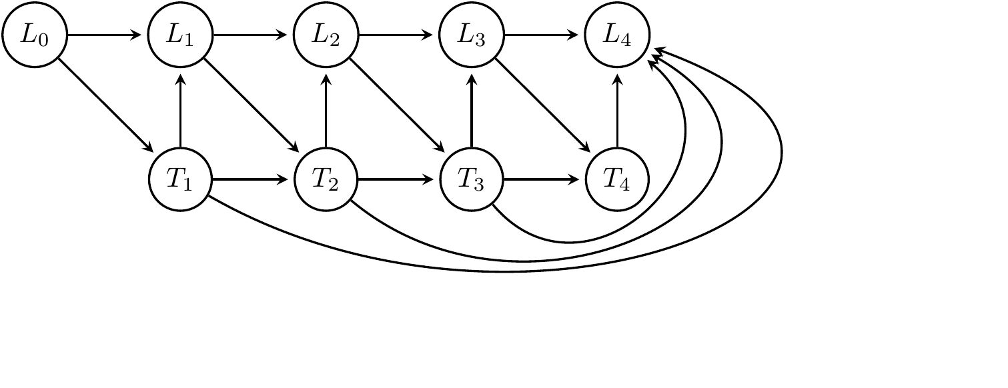

Figure 1S: Directed Acyclic Graph of an idealized version of our causal model. L represents the set of covariates and outcomes (MDS-UPDRS scores, MoCA, MSE-ADL, etc.) and T represents the treatment indicator. In addition, we assume there are background variables (age, sex, education, time since diagnosis) that may influence both treatment decisions and the covariates in L, and the full history of treatment decisions may influence the current disease state (not shown, except for the last node).

A simplified version of the underlying causal model we assume in this work is shown in figure 1S. L in this figure denotes the time-varying confounders at each stage. These are formed by patient characteristics at each visit, and we assume they are adequately captured by the MDS-UPDRS part scores, MoCA and MSE-ADL in addition to the background characteristics of the patient: Age, Sex, Years of Education and disease duration. An important insight from this model is that merely correcting for baseline measurements and characteristics is not enough to estimate the causal effect of intervening on the lenght of therapy in the first two years. Failing to properly adjust for the patient characteristics at each treatment decision could, for instance, improperly attribute longer therapy with bad outcomes, simply because the groups of patients that started medication therapy earlier, already had a more advanced state of the disease when the decision to start medication therapy was made. This confounding effect is known as time-varying confounding. The inverse probability of treatment weighting (IPTW) and g-formula methods used in this work offer a way to adjust for this time-varying confounding, either by reweighting patients in such a way that in the reweighted sample the chance of receiving each treatment no longer depends on the covariates at each stage, or by modelling and simulating disease trajectories under all possible treatment assignments for each patient.

In the models for IPTW, at each time point we estimate the prior probability of starting treatment for those that have not started yet. We then estimate the probability of starting treatment for those that have not started yet given the covariates (age, sex, years of education, disease duration, MDS-UPDRS part scores, MSE-ADL and, if available, MoCA score) of the previous visit, using a logistic regression model. We divide the prior of the observed decision (started vs. not-started) by the probability of the observed decision given by the logistic regression model. By multiplying these weights for the different time-points, we get a final weight that is used for estimating the marginal structural model. For censoring in the IPTW models, we use the same procedure as for the treatment weights, and multiply the final weight by the final weight given by the treatment models to get an overall weight which we use in the marginal structural model.

In the marginal structural model, we use a linear model of the length of treatment and, in most analyses, adjust for the outcome measured at baseline (indicated here are “Baseline Adjusted”). In this supplement, we also report results when adjusting for all baseline variables, not just the particular outcome of interest (indicated by “Baseline Adjusted All”), and with and without adjustment for censoring using inverse probability of censoring weighting (indicated by “Censoring”). We also show results when adjusting for outcome at baseline and the Levodopa Equivalent Daily Dose of the patient at the time of the outcome measurement (indicated using “LEDD”). While this latter model may seem to be sensible to adjust for the long duration response of medication on the measurement, the causal interpretation of these results is not straightforward, since LEDD is likely influenced by the treatment decision whose effect we are trying to estimate. Finally, we use a linear regression model both for the continuous as well as for the dichotomous outcomes, which allows for both a uniform implementation of the models and presentation of the results. For the dichotomous outcomes, a logistic regression model would have been a sensible alternative choice.

For the parametric g-formula, we use linear regression models. We allow for treatments earlier than the current visit to influence the prediction of the next observation. These links are not shown in the causal model, but are reflected in the fitted model which contain the observed values of the covariates at the previous available time-point (and the baseline measurements, for the predictions at the final time-point) and all available previous treatment decisions. The variables that are included are treatment status, age, sex, years of education, disease duration, MDS-UPDRS part scores, MSE-ADL and, for yearly measurements, MoCA score. To take the correlations between the time-varying covariates at each time point into account, we iteratively add the variables for the current time-point to the models, in the order just mentioned. For instance, the model to generate the current MDS-UPDRS part I score only contains variables from the previous visit, while the model for the current part II score includes the current part I score, and the model for the part III score includes the current part I and part II scores. Using these models, for each patient from the subpopulation of interest, for each of the 5 possible treatment decisions, we simulate 100 trajectories for the covariates and outcomes, which, in the analysis where we consider 5 options for the treatment length and the whole sample at baseline, gives (416*5*100=208000) trajectories. We use the same marginal structural model on these simulated outcomes as used in the IPTW method to generate the final estimates.

# Supplementary Results

## Table 1S. Descriptives

Table 1S. Baseline characteristics for groups of different Parkinson Medication duration during the first two years since the start of the study. For continuous measures, we show the mean (standard deviation). For dichotomous measures, we show the proportion. Treatment Length indicates the number of years of PD medication treatment received by each group during the first 2 years since the start of the study, where Censored refers to the group of patients for whom no complete follow-up was available for the first two years. NA indicates number of missing values.

|  |  |  |  |  |  |  |
| --- | --- | --- | --- | --- | --- | --- |
| Treatment Length | 0 | 0.5 | 1 | 1.5 | 2 | Censored |
| n | 58 | 37 | 54 | 180 | 31 | 56 |
| Age (Years) | 61.9 (10.6) | 60.0 (9.0) | 62.9 (9.9) | 61.5 (9.5) | 59.1 (10.9) | 63.2 (8.2) |
| Gender (% Men) | 0.60 | 0.62 | 0.69 | 0.67 | 0.71 | 0.66 |
| Education (Years) | 15.6 (2.7) | 16.0 (2.1) | 16.0 (2.5) | 15.4 (3.1) | 15.4 (3.0) | 15.2 (3.6) |
| Disease Duration (Years) | 0.8 (0.7) | 0.6 (0.5) | 0.6 (0.6) | 0.5 (0.5) | 0.4 (0.3) | 0.5 (0.5) |
| MDS-UPDRS I | 4.7 (3.3) | 5.1 (4.0) | 5.9 (4.2) | 5.6 (3.9) | 6.3 (5.3) | 5.8 (4.1) |
| MDS-UPDRS II | 3.7 (2.9) | 4.6 (3.2) | 5.7 (4.0) | 6.7 (4.4) | 6.3 (4.0) | 6.4 (4.6) |
| MDS-UPDRS III | 18.0 (7.8) | 18.0 (7.7) | 21.7 (9.3) | 22.2 (8.6) | 17.5 (8.7) | 22.4 (9.7) |
| MoCA | 27.1 (2.5) | 26.9 (1.8) | 26.9 (2.5) | 27.2 (2.3) | 27.0 (2.9) | 27.4 (2.1) |
| MSE-ADL | 95.4 (4.8) | 93.5 (6.0) | 93.1 (5.0) | 92.7 (6.2) | 92.1 (6.6) | 92.8 (6.0) |
| QUIP-S (% any) | 0.24 | 0.16 | 0.23 | 0.19 | 0.16 | 0.23 |
| LEDD at 2 years | 0.0 (0.0) | 241.5 (232.6) | 274.0 (172.4) | 414.5 (324.9) | 432.7 (244.0) |  |
| LEDD at 3 years | 125.1 (165.9), NA:6 | 326.3 (249.6), NA:2 | 337.4 (218.0), NA:2 | 525.1 (365.8), NA:12 | 564.0 (235.7), NA:3 |  |
| LEDD at 4 years | 257.2 (244.9), NA:7 | 384.2 (275.2), NA:8 | 425.9 (240.9), NA:8 | 596.1 (379.9), NA:23 | 630.2 (294.4), NA:3 |  |

## Table 2S. Medication types

Table 2S. Distribution of types of medication use for patients in the different groups at year 2, according to questions answered by the investigator. Lv: levodopa; Ag: agonist.

|  |  |  |  |  |  |  |  |  |
| --- | --- | --- | --- | --- | --- | --- | --- | --- |
| Years Treatment | Missing | Lv | Ag | Other | Lv+Other | Lv+Ag | Ag+Other | Lv+Ag+Other |
| 0.5 | 0.03 | 0.27 | 0.22 | 0.41 | 0.00 | 0.03 | 0.03 | 0.03 |
| 1.0 | 0.00 | 0.35 | 0.19 | 0.28 | 0.02 | 0.04 | 0.13 | 0.00 |
| 1.5 | 0.00 | 0.31 | 0.22 | 0.16 | 0.08 | 0.08 | 0.13 | 0.03 |
| 2.0 | 0.00 | 0.45 | 0.16 | 0.13 | 0.10 | 0.06 | 0.06 | 0.03 |

## Figure 2S. MDS-UPDRS I, II, III, MoCA, MSEADL – Any PD medication - only starters



Figure 2S: Effect of a year of PD treatment (any medication) during the first two years of follow-up (estimated using only those patients who were using medication at the time of the outcome measurement). Effect on the score of different outcomes measured at year 2, 3 and 4.

## Figure 3S. MDS-UPDRS I, II, III, MoCA, MSEADL – Any PD medication - Whole population



Figure 3S. Effect of a year of PD treatment (any medication) during the first two years of follow-up (extrapolated to the whole study population). Effect on the score of different outcomes measured at year 2, 3 and 4.

## Figure 4S. MDS-UPDRS I, II, III, MoCA, MSEADL – Only levodopa - Only starters



Figure 5S: Effect of a year of PD treatment (exclusively levodopa) during the first two years of follow-up (estimated using only those patients who used levodopa exclusively during the first two years). Effect on the score of different outcomes measured at year 2, 3 and 4.

## Figure 5S. Dyskinesias, motor fluctuations, QUIP – Any PD medication - Only starters



Figure 5S: Effect of a year of PD treatment (any medication) during the first two years of follow-up (estimated using only those patients who were using medication at the time of the outcome measurement). Effect on the score of different outcomes measured at year 2, 3 and 4.

## Figure 6S. Dyskinesias, motor fluctuations, QUIP – Any PD medication - Whole population



Figure 6S: Effect of a year of PD treatment (any medication) during the first two years of follow-up (extrapolated to the whole study population). Effect on the score of different outcomes measured at year 2, 3 and 4.

## Figure 7S. Dyskinesias, motor fluctuations, QUIP – Only levodopa - Only starters



Figure 7S: Effect of a year of PD treatment (exclusively levodopa) during the first two years of follow-up (estimated using only those patients who used levodopa exclusively during the first two years). Effect on the score of different outcomes measured at year 2, 3 and 4.

# Non-linearity of the effect

In the results above we assumed in the marginal structural model that the effect of treatment was linear: adding half a year of treatment has the same effect regardless of whether one goes from 0 years of treatment to 0.5 year of treatment or from 1.5 years of treatment to 2 year of treatment. Here we estimate how the effect differs for different time points. “Treatment @ 2” refers to having treatment at year 2 (so in the final six months), Treatment 1.5 is between year 1 and 1.5, etc.

## Figure 8S. Non-linearity of the effect IPTW – Only starters

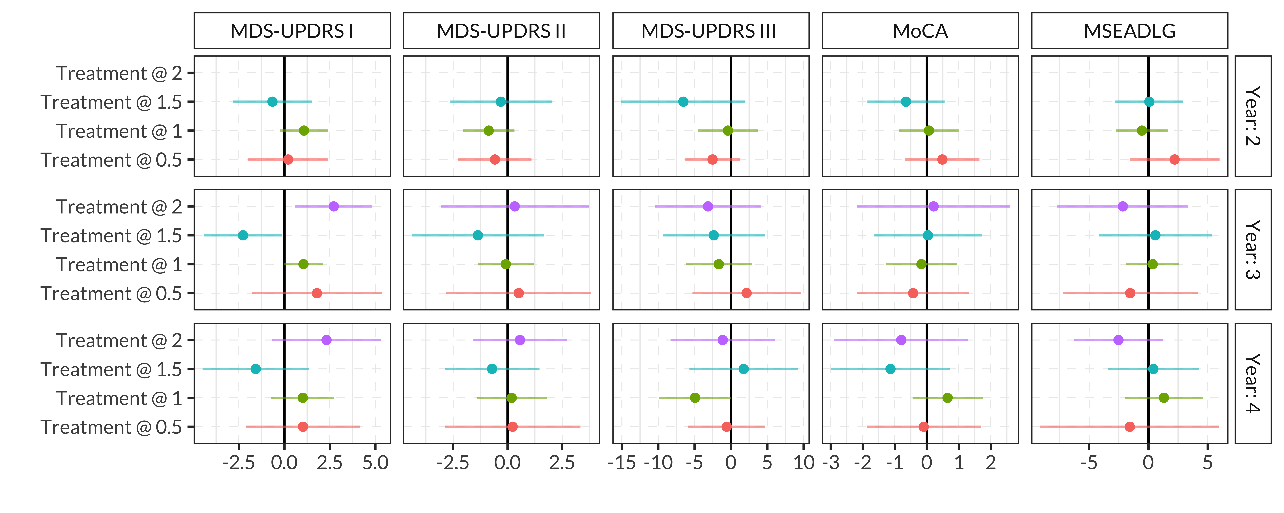

Figure 8S: Additive effect of treatment (any medication) being active at different time-points during the first two years for the IPTW model for only those patients who had started medication treatment at the time of the outcome measurement (hence all have active treatment at time 2). Effect on the score of different outcomes measured at year 2, 3 and 4.

## Figure 9S. Non-linearity of the effect g-formula – Only starters

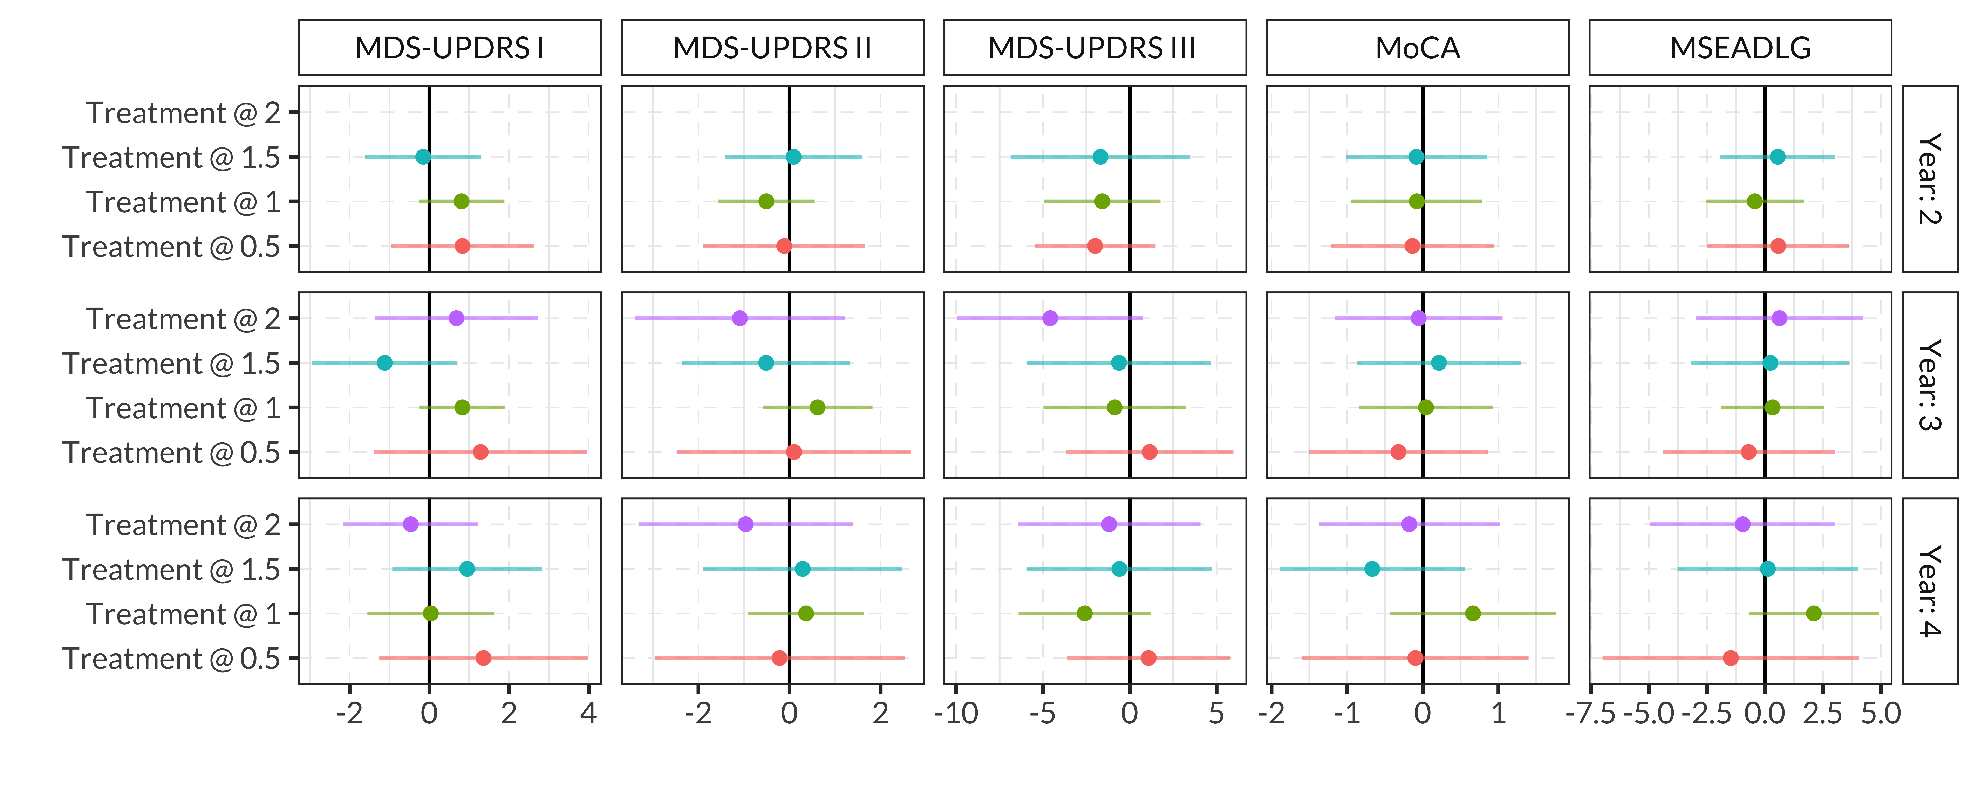

Figure 9S: Additive effect of treatment (any medication) being active at different time-points during the first two years for the g-formula model (estimated using those patients who had started medication treatment at the time of the outcome measurement). Effect on the score of different outcomes measured at year 2, 3 and 4.

# Effect modification

To estimate the potential modification of the effect of different baseline characteristics of the patient, using the inverse probability of treatment weights for each outcome/year we estimate a marginal structural model containing main effects and interaction terms with treatment length for age, sex, disease duration and three MDS-UPDRS subscores at baseline in a single model.



Figure 10S: Interaction effects in the IPTW Marginal Structural Model (main effects not shown), for the length of PD treatment (any medication) in the first two years of follow-up, estimated using patients who had started medication therapy at the time of the outcome measurement.